* Prayer of Dedication

* Hymn #21 (The Hymnbook) “Joyful, Joyful, We Adore Thee”

* Benediction

* Choral Benediction

The Postlude

**Session**

Brook Bockhorn Marvin - Christian Education

Scott Carlson - Mission & Benevolence

Elizabeth Smith Lehrmann - Congregational Care

Jerry Newman - Worship

Tom Newman - Building & Grounds

Geneva Aguilar Winkelmann - Fellowship, Church Growth

Clerk to Session: Rosellyn McIver and Interim Treasurer:Todd Gray

Today’s Liturgist: Bess Newman

*Our guest minister,* ***Tom Currie*** *is a retired Presbyterian minister. He served as pastor of the Brenham Presbyterian Church from 1976 to 1988. He also served as pastor of First Presbyterian Church in Kerrville, Texas, before becoming dean of Union Presbyterian Seminary’s campus in Charlotte, North Carolina. He and his wife, Peggy, currently live in Georgetown. Their son, Chris, who grew up in this congregation, is the pastor of the St. Charles Ave. Presbyterian Church in New Orleans. Chris and his wife, Stephanie, have three children. The Currie’s daughters, Kate and Anne were also born in Brenham. Kate lives in San Antonio with her husband, Chad, and their two girls, Birdie and Evie. Anne lives and works in Austin.*

**Our Mission Statement**

Gather to worship God and know His Word

Grow in our relationship with God

Go into the world to serve

*We rejoice with parents Tom and Emily Newman,*

*big sister and brother, Kate and Tom, Jr. as their new baby,*

***Jane Margaret Newman*** *receives the sacrament of baptism in worship today.*

*\* Congregation please stand www.brenhampresbyterian.org*

**Brenham**

**Presbyterian Church**

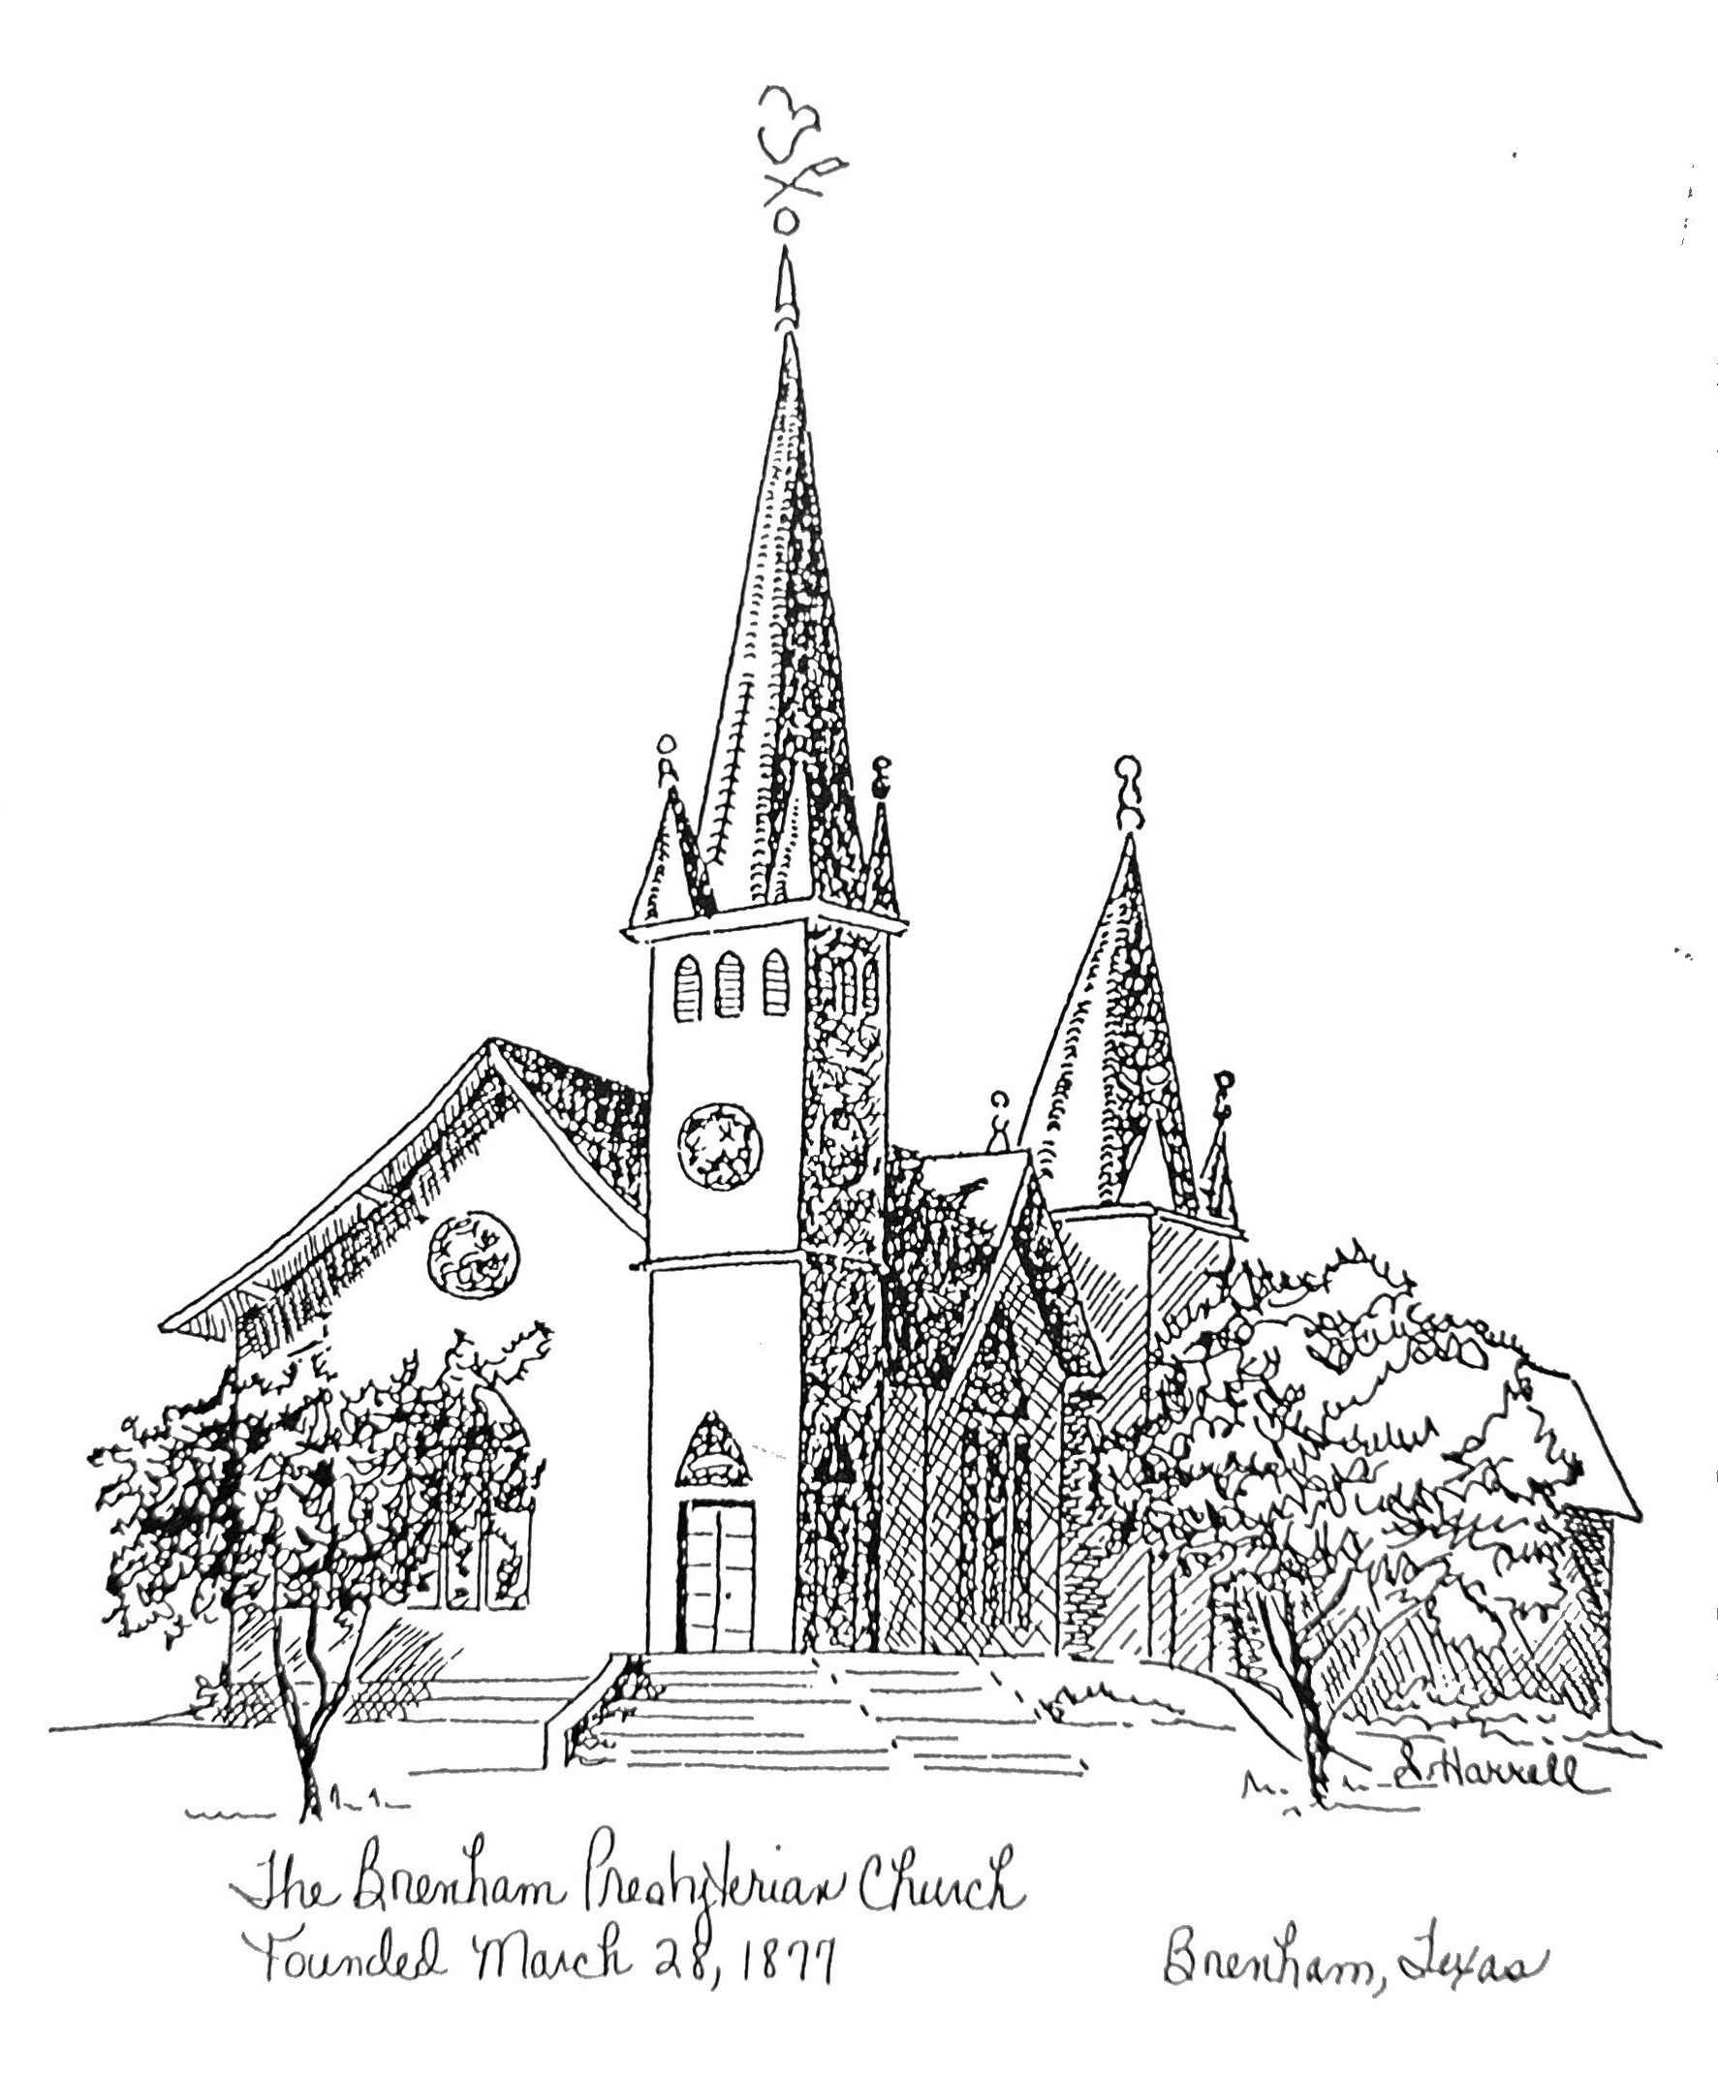

**Founded 1877**

**Brenham Presbyterian Church**

**Order of Worship**

**August 11, 2024**

**Nineteenth Sunday in Ordinary Time**

Welcome and Announcements

The Prelude

Tolling of the Bell

Call to Worship

*Leader:* Out of the depths I cry to you, O Lord, Lord, hear my voice!

***People:* Let your ears be attentive to the voice of my supplications!**

*Leader:* I wait for the Lord, my soul waits, and in his word I hope.

***People:* My soul waits for the Lord more than those who watch for the**

**morning, more than those who watch for the morning.**

*Leader:* Our help is in the name of the Lord, who made heaven and earth.

***People:* Let us worship God.** *(Ps.130:5,6; Ps.124:8)*

* Opening Hymn #385 (Glory to God Hymnal) “All People That on Earth Do Dwell”

* Prayer of Adoration *(unison)* **Almighty and everlasting God, you are more ready to**

**hear than we to pray, and you give us more than we desire or deserve: Pour down**

**upon us the abundance of your mercy so that we might worship you aright and gladly**

**voice our praise and thanksgiving. We ask this in the name of our Lord and Savior,**

**Jesus Christ. Amen.**

Assurance of Pardon “Now all the tax collectors and sinners were coming near to listen to him. And the Pharisees and the scribes were grumbling and saying: ‘This fellow welcomes sinners and eats with them.’” *(Luke 15:1,2)*

Prayer of Confession *(unison)* **Eternal God, our Judge and Redeemer: we confess that we have tried to hide from you by loving the darkness more than the light. We have lived self-centered lives and have daily attempted to deceive ourselves and you. Forgive us. Grant us faith to live in your light and walk in your ways and to be unashamed to be called your children. We ask this in the name of him who welcomed sinners and ate with them, even Jesus Christ our Lord. Amen.**

The Commandments *(unison)* **“Which of these three, do you think, was a neighbor to the man who fell into the hands of the robbers? He said, ‘The one who showed him mercy.’ Jesus said to him, ‘Go and do likewise.’”** *(Luke 10: 36,37)*

Musical Reflection

The Sacrament of Baptism: Jane Margaret Newman

Unison Scripture Reading (Selection 45) - Page 518 in the back of The Hymnbook

* Hymn #390 (The Hymnbook) “Open My Eyes, that I May See”

Prayer of Illumination

Scripture: Ephesians 4:25-5:2

* Hymn #738 (Glory to God Hymnal) “O Master, Let Me Walk with Thee”

Sermon “…Him Serve with Mirth…” Tom Currie

* Confession of Faith: The Apostles’ Creed

**I believe in God, the Father Almighty, Maker of heaven and earth. And in Jesus Christ his only Son, our Lord; who was conceived by the Holy Ghost, born of the Virgin Mary, suffered under Pontius Pilate, was crucified, dead, and buried; he descended into hell; the third day he rose again from the dead; he ascended into heaven, and sitteth on the right hand of God the Father Almighty; from thence he shall come to judge the quick and the dead. I believe in the Holy Ghost; the holy catholic church; the communion of saints, the forgiveness of sins; the resurrection of the body; and the life everlasting. Amen.**

* Gloria Patri “Glory Be to the Father”

Prayer of Intercession and The Lord’s Prayer

Congregational Response “Hear Our Prayer, O Lord”

Giving of Tithes and Offerings (Choir Anthem)

* Doxology